LINUXII EXERCICES FINAL

1. Run the command in order to:

(a) Change to your personal directory

(b) Show your current directory
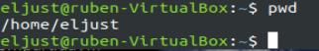

2. Create the following structure of directories from your personal directory:

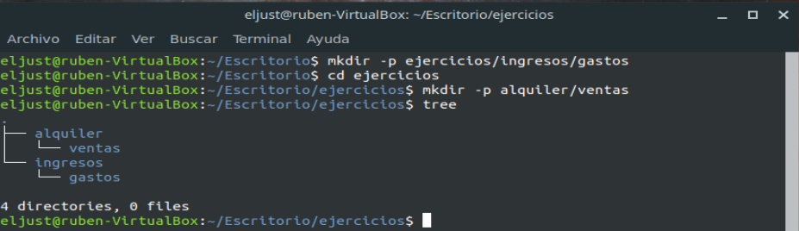
3. Move from the current directory to the gastos directory. Create 2 files emple1.txt and emple2.txt. Later, write 3 words in each row in each file: oak, tiger, home.

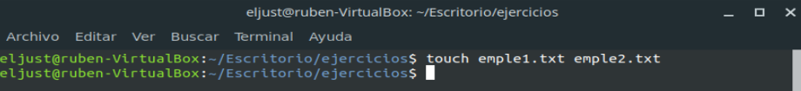
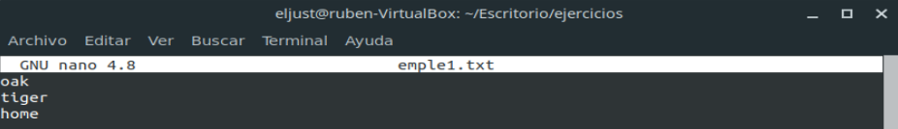
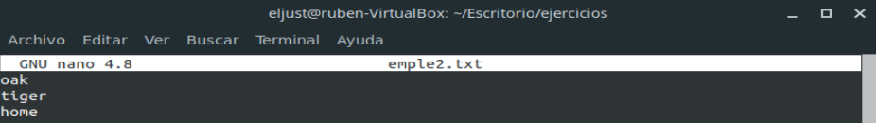
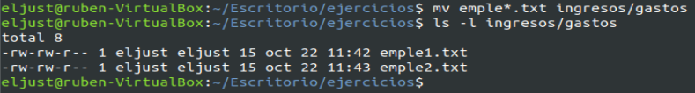

4. Check if emple1.txt is ordered. If it isn't, order it.

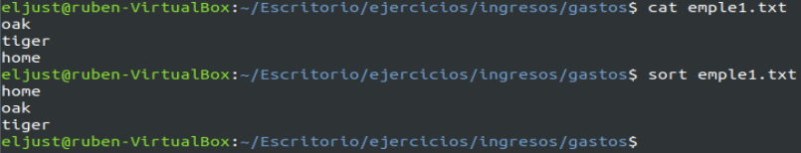

5. Using wildcards, copy emple1.txt and emple2.txt to ventas, staying in gastos directory and using relative path.

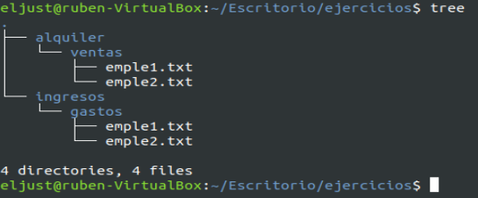

6. Move emple1.txt and emple2.txt to alquiler using wildcards. Stay in gastos directory
and using absolute path.

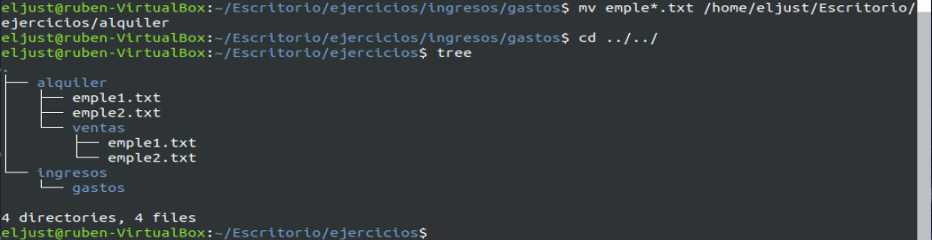
7. Go to the root directory and show the list of all the files in large format.
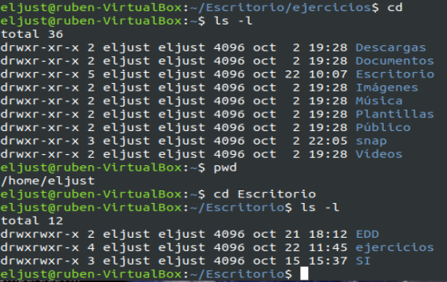

8. Come back to gastos directory using the command to do this. Go to alquiler directory using a relative path and show the numbers of the emple1.txt file.

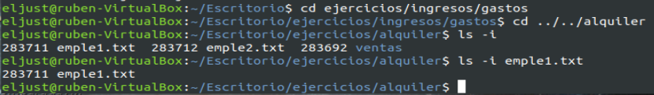

9. Do this:

(a) Create a hard link to emple2.txt called enlace2.txt.
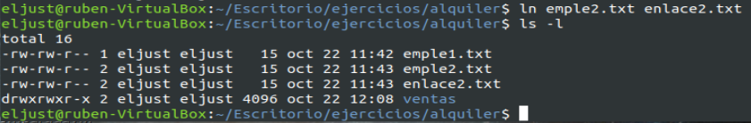

(b) Modify hard link enlace2.txt, and check if emple2.txt has been modified.

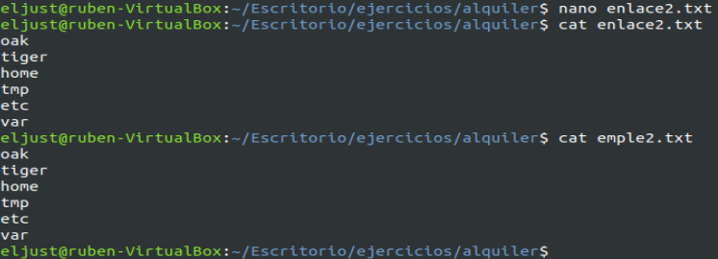

(c) Create a symbolic link to emple1.txt called ensim1.txt.
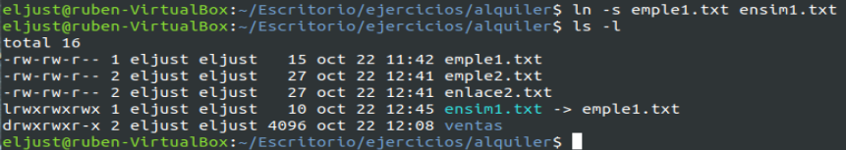

(d) In large format show the list of all the directories and cut the first character.

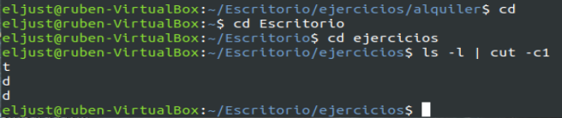

10. Remove all the directories and files which have been created in this section of exercises.

